1.Write a C++ program for sum of two number using class and object. Use getdata and putdata as a member function.

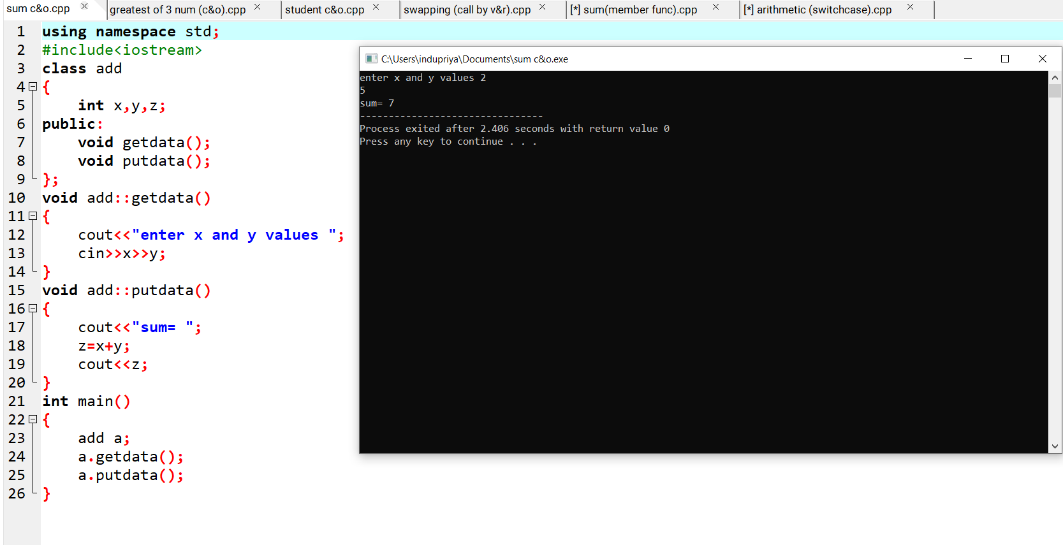

2.Write a C++ program to find the biggest of three numbers using class and object.

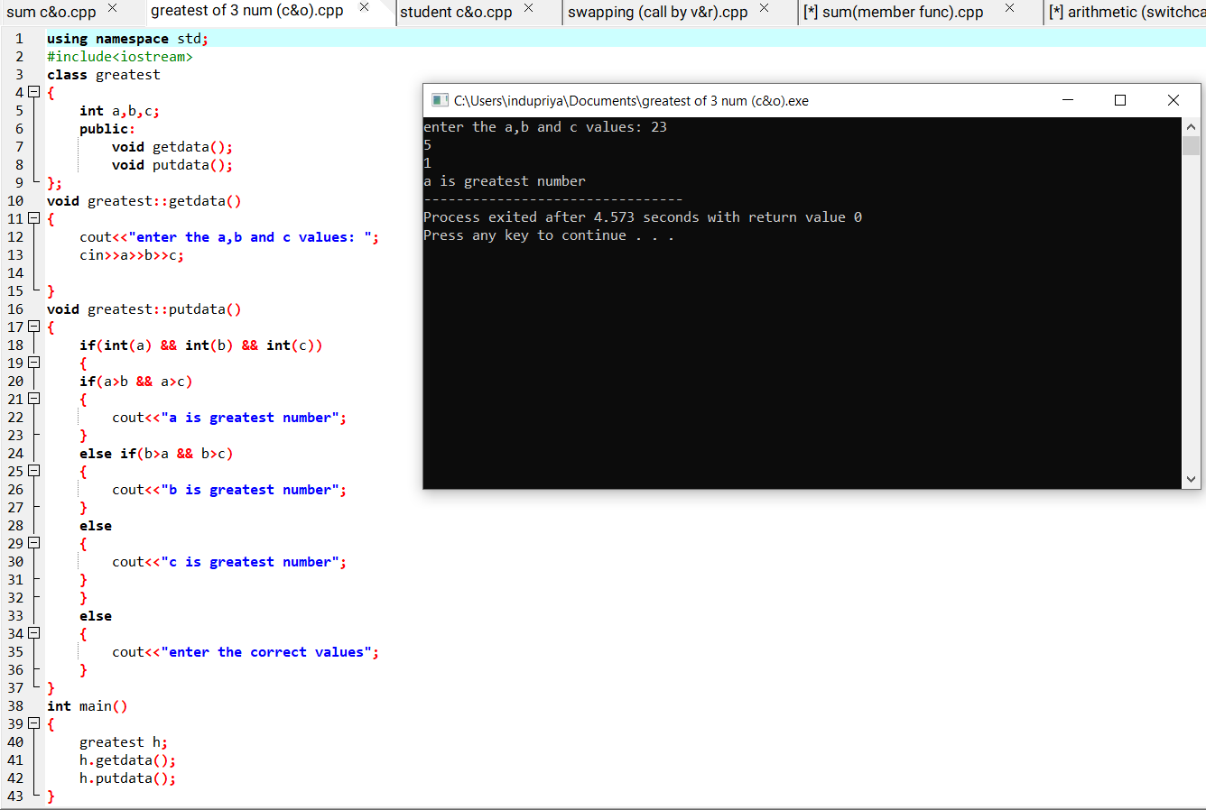

3.Write a C++ program to student report using class and object.

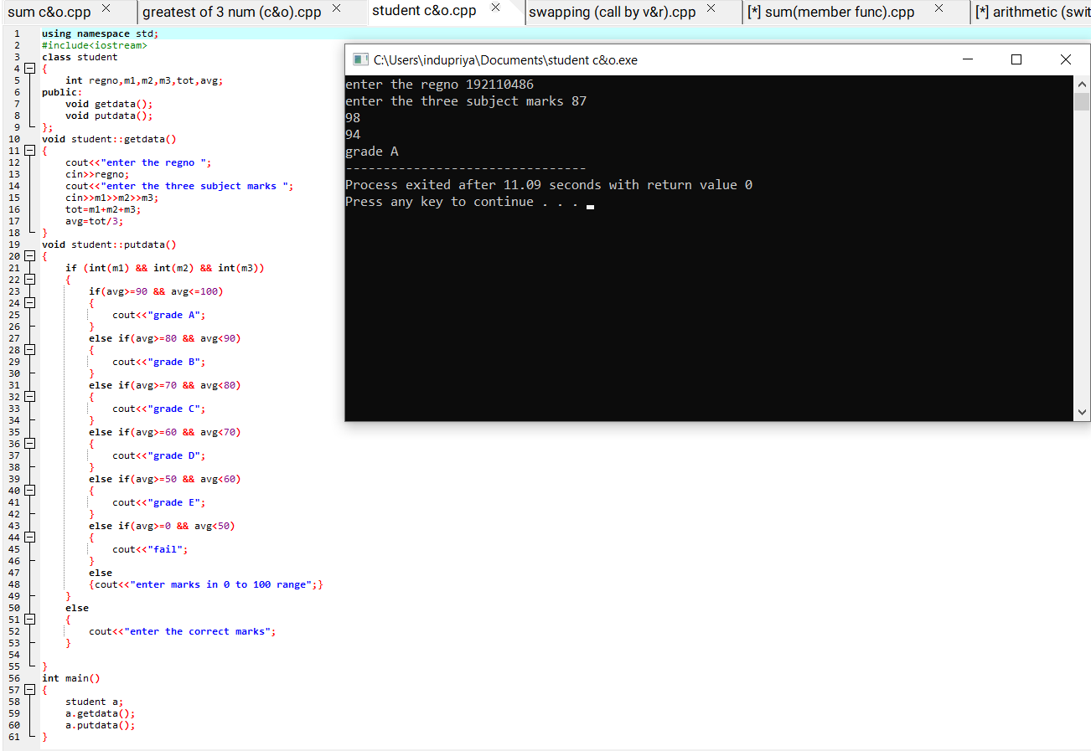

4.Write a C++ program arithmetic operations using switchcase.

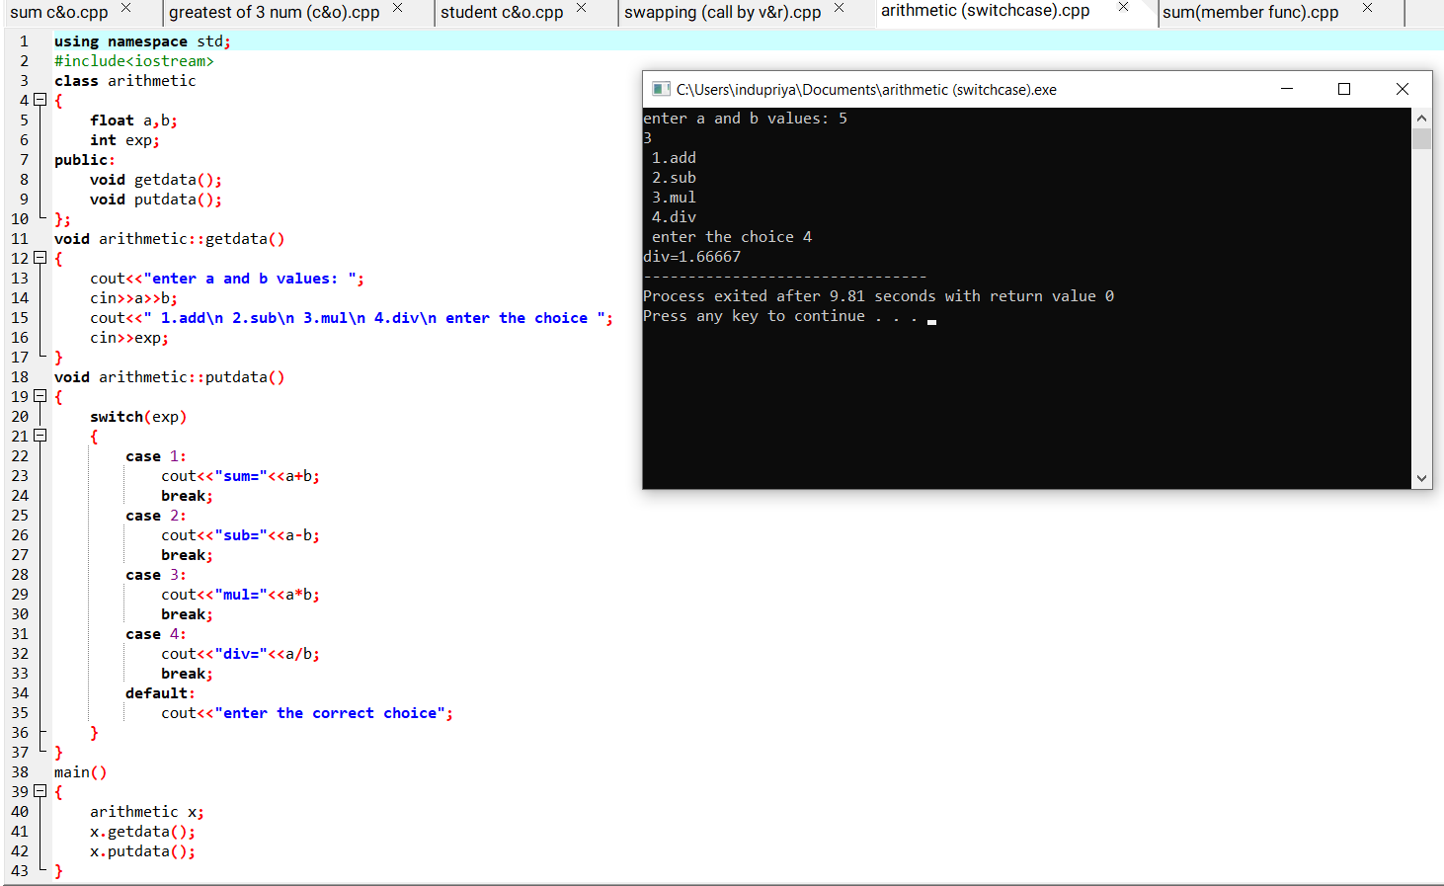

5.Write a C++ program to find the sum of numbers using member function

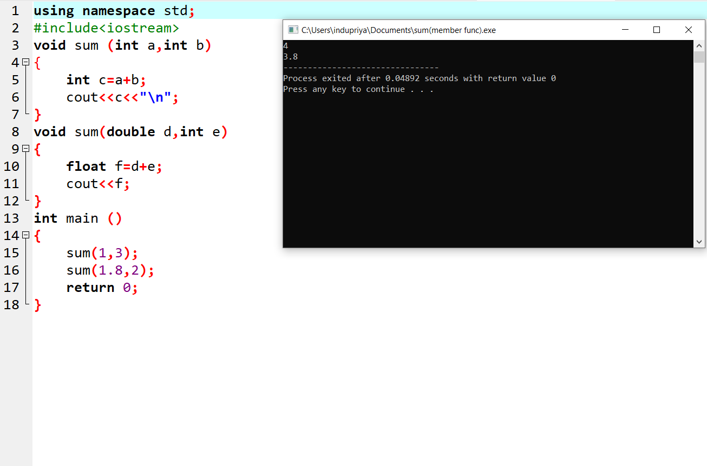

6.Write a C++ program for swipping of two number using call by value and call by reference

. 